CodeMaker! Note Naming Music Lesson Plan
Practice drawing treble and bass clefs

Grades K-2 Draw at least five treble clefs and five bass clefs (Use CodeMaker worksheet)
Grades 3-5 CodeMaker Activity

Objective
Practice note names of the treble or bass clef.
Standard #5 National Standards for Music: Reading and notating music.

Materials

CodeMaker! Note Name Worksheet Treble Clef or Bass Clef
Pencils

CodeMaker!
Step 1
Review the note names below
Step 2
"The challenge of this activity is to come up with as many words as you can using only the letters of the musical alphabet. (It's okay to repeat letters.) After you have written the words in the blanks below the staff, turn them into code by writing the words in music notes on the staff above the word."
Step 3
Begin brainstorming for words. You must spell the words out in music notes for the word to count.
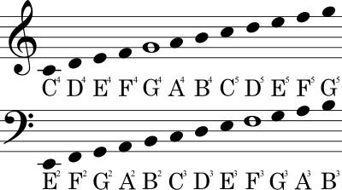
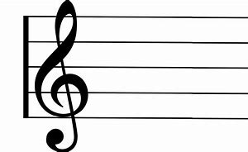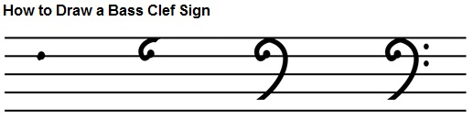

3rd-5th Grade -Example: C A T write the word on the line and draw the notes on the staff to match the letters
K-2nd grade students, you do not have to draw the notes. Draw at least five treble clefs and five bass clefs. The treble clef is also known as the G Clef.
Resource: Lesson Zone

